**First Semester 2023-24**

**Data Structures and Algorithms Design (Merged-SEZG519/SSZG519)**

**LAB 5 (Algorithm Design Techniques)**

*Notes: This lab covers the practicals on Algorithm Design Techniques. We have mentioned programs in C language in the lab sheet. However, students are free to choose any of the programming languages to develop the solution to lab tasks.*

1. Complete the following code to implement Huffman coding.

|  |
| --- |
| #include <stdio.h>  #include <stdlib.h>  void HuffmanCodes(char data[], int freq[], int size)  {  //Write your code here...  }  int main()  {  char arr[] = { 'a', 'b', 'c', 'd', 'e', 'f' };  int freq[] = { 5, 9, 12, 13, 16, 45 };  int size = sizeof(arr) / sizeof(arr[0]);  HuffmanCodes(arr, freq, size);  return 0;  } |

1. Execute Prim’s and Kruskal’s algorithm on the following graph and identify the output of both algorithms.

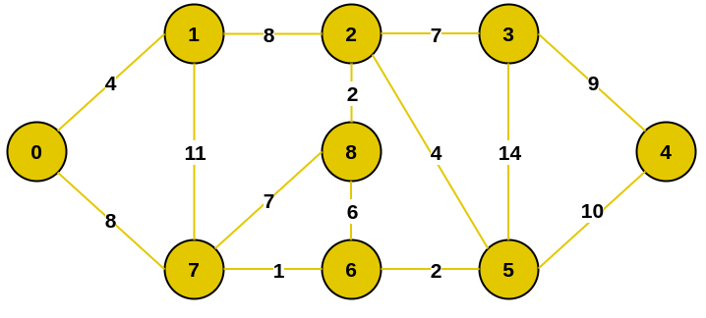

1. Execute the Merge sort code on the following sample inputs and fill the table of Merge sort’s execution time.

|  |  |  |
| --- | --- | --- |
| **Sample input** | **Execution time** | **Your observation** |
| Array of 100 elements in decreasing order |  |  |
| Array of 100 elements in increasing order |  |
| Array of 100 elements where first 50 in increasing order and next 50 in decreasing order |  |
| Array of 100 elements where first 50 in decreasing order and next 50 in increasing order |  |

1. Execute the quick sort code on the following sample inputs and fill the table of quick sort’s execution time.

|  |  |  |
| --- | --- | --- |
| **Sample input** | **Execution time** | **Your observation** |
| Array of 100 elements in decreasing order | 1) ___ when first element as pivot  2) ___ when last element as pivot  3) ___ when mid element as pivot |  |
| Array of 100 elements in increasing order | 1) ___ when first element as pivot  2) ___ when last element as pivot  3) ___ when mid element as pivot |
| Array of 100 elements where first 50 in increasing order and next 50 in decreasing order | 1) ___ when first element as pivot  2) ___ when last element as pivot  3) ___ when mid element as pivot |
| Array of 100 elements where first 50 in decreasing order and next 50 in increasing order | 1) ___ when first element as pivot  2) ___ when last element as pivot  3) ___ when mid element as pivot |

1. Execute Dijkstra’s and Bellman Ford algorithm on the following graph. Compare the output of both algorithms.

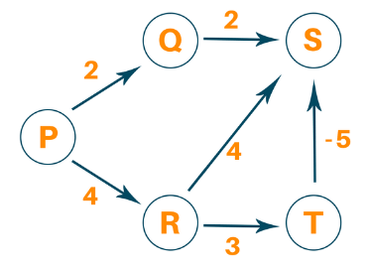

1. Execute Floyd Warshall algorithm on the graph shown in question 5 and identify the output.